Thursday Renju Class in 5lin.

- 教育訓練組 對 ○助教
Opening i6.

Every Thursday, during 9.30 p.m. – 11.00 p.m. several renju fans gather in 5lin classroom to take part in weekly renju class. In that class we study renju openings, we try to learn to understand the essence of each opening, therefore we always try to explain about each variant as much as possible. We also give homework for our students in the end of each class. However, 1.5 hours is not long time, so we do not always study every possible move in openings.
As there are many renju players who do not have time to join renju class in 5lin at Thursdays, as there are many renju players playing other sites (Acer, BBS, etc.), as there are many people without Internet access, therefore we decided to publish the 5lin class materials in this magazine so that everybody can read them.
My greatest thanks to 奕學, fivestar, finite555, 紫雲仙 and others who are always kindly assisting the class under the name 助教 ! ^_^

Jan 6 23:18
Hello everybody! So nice to be together again after 2 months. ^_^ Today I want tell you about i6 opening. About 10 years ago, when i was new player, i very loved this opening. Because everybody knew this opening is strong for black, but I still tried to find some good ways for white to survive. Sometimes I discovered very strong defense moves for white and therefore I even used this opening as white in World Championship in 1993. But after many years of serious study, I have finally reached to conclusion that black wins 95% sure in everywhere in this opening.
In this opening there are 5 different ways for white's 4th move. When I was younger, I liked all those 4th moves, and I studied them a lot.
I just want to tell you, if you do not know how black must play in this opening, then you will have very big problems as black ... So, we will take a look at all possible white 4th moves and study black correct attack after these 4th moves.
The possible choices for white are: h9, g8, j8, h7, j7.
Other 4th moves are not serious and black can win very easily. You can choose which 4th move you want to study first. ^^ OK, we study h9.
I remember, 10 years ago I tried to search for defense ideas for white here, but I had to give up very soon because black is too powerful.
The 5th moves are g8 and g9.
These two 5th moves give sure win for black. Of course there are other possible 5th moves too, but they are not so strong.
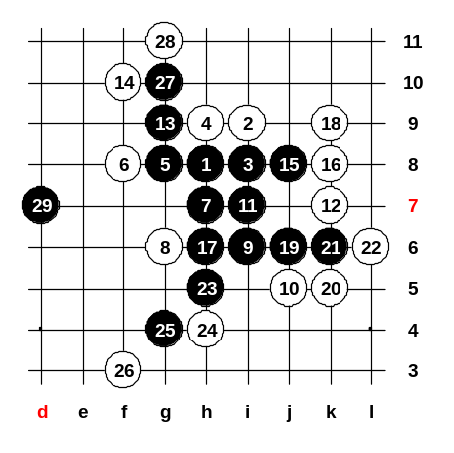
For example, 5-g10 (d3 opening) or 5-g7 (i11 opening) or 5-g6 (i12 opening).
Do you understand this?
The main 5th move is g8, so we will try it first.
The 6th move bust be played f8, of course.
This 7th move looks strong but it is still not very easy to win. The two best white stops are 8-g6 and 8-i6.
Try 8-g6 now.
(If 10-f9 then 11-g9 and black still wins.)
Now 12-k7 !! Very strong stop!
Black win is very difficult!
Remember the black steps, the win is beautiful!
Now after 17th move white has two ways to stop, we will show diagram for both ways. After 29th move black has two VCF threats, so black wins.

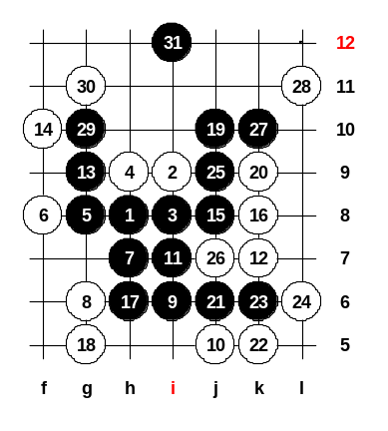
Jan 6 23:22
The first 17 moves are same, we change the 18th move. 18-g5.
19-j10, very beautiful win-move. If 20-j9 then black attack goes k9, m7, i5, j4, k5 (4x3). So we try 20-k9 here. Two 4x3 wins after 31st move. As you can see, in such opening black must use nearly all his power all around to connect together into winning attack.

Jan 6 23:23
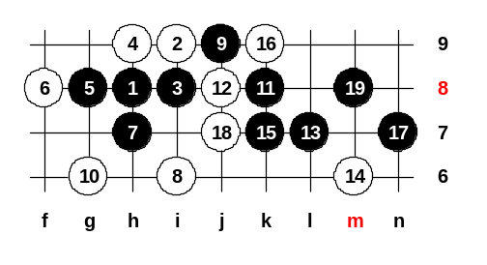
We will look another 8th move now: 8-i6. The 9th is very logical move. Of course 10 must be g6. The 15-k7 - This is very classical black attacking style. The 17-n7 !! The win-move!! You can see the connection with k10-point. And because of k10, m8, k6 danger, white must play 18-j7. After 19th move black wins. You can try to find the black win yourself here later. Yeah, we may leave it as homework. We have 25 minutes left, we still need to study the other 5th move too.

Jan 6 23:25
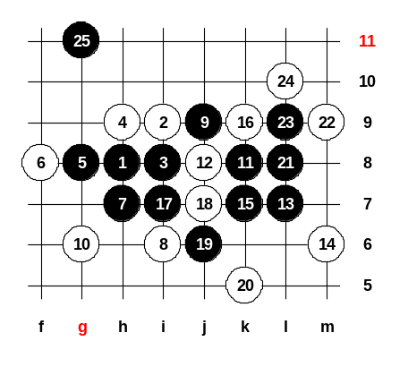
We try another test for win now, as mirageled says. mirageled says 17-i7 is easy win. We must look it. As I remember, the win has problem here because white always has something to defend with. And now after 24th move, even though black seems to have plan to connect the attack through i12 and g10, there doesn’t seem to be any possible sequence for that. Every time white seems can stop it, no matter how black begins the attack. Today we didn't have a chance to look the other 5th move.
Do you have any questions about this 5th move before we finish the lesson?
I suggest everybody to study this situation on this board and try to make sure if black can or cannot win here.
Finally, somebody found black win, 25-g11, congratulations! ^_^
We have two different wins now after that 8th move. As there seem to be no questions, I will announce today's class to be finished. Have a good night ^_^

peter_w : Jan 8 11:42
After 26, 27-j11 is double 43 threat.

peter_w : Jan 8 11:43
Can 23-L10 win more quickly?

教育訓練組 : Jan 13 23:15
No, if 23-L10 then 24-L11.

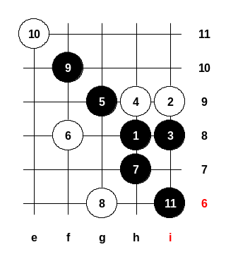
Jan 13 23:08
Welcome to the Thursday Renju Class ^_^ Today we continue looking the i6 opening.
Last time we looked 4-h9, but we only had time to study one 5th move there. Today we will also look the other 5th move. 4-h9, 5-g9. There are several 6th moves possible. However, they all lose very fast, except 6-g8 and 6-g7. And one more interesting move 6-f8. But 6-f8 loses fast too. Let me show you. The 11-i6 is a beautiful move, it creates very strong base for black attack. If 10-i7 then 11-e10, win! Let’s open new board, I will show you other 6th move. This diagram is finished because black wins easily now. If you have any questions, always please ask immediately.

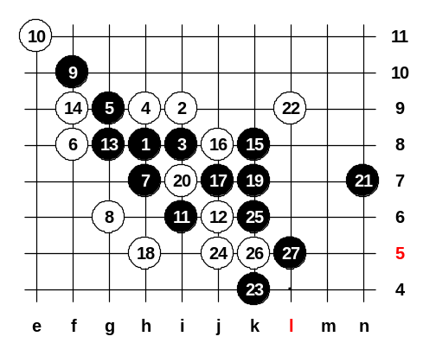
Jan 13 23:09
We play the last diagram till the end now. So, you can suggest moves for white, I will play black moves myself. This was an example black attack. I am sure black could win in very many ways in that position. ^^

Jan 13 23:10
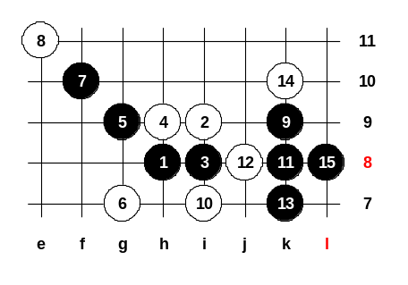
Now, 6-g7. Now, black has three good choices for 9th move. Old Japanese book suggests 9-i10. Russian book says 9-k9. But I have found another good move too, 9-g6. Let’s continue with Russian style this time. 10-i7. Black plays 2 threes and then puts a strong development move. Black has sure win here now. If somebody want, can study at home about Japan style (9-i10) or my style (9-g6). I am sure you can self find some good winning ideas there, too. I would like to keep the position as it is now, then people will know it is the standard situation. Because white can now try so many moves, we don’t have time to look every move. Black win is really easy here. And if white will try to attack self, then black just stops in the simple way - 16-f7, 17-h7, 18-i10, 19-g8 and white attack is dead.

Jan 13 23:11
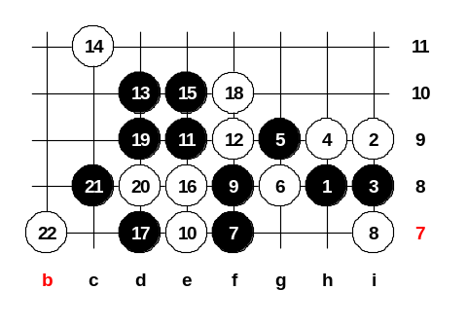
The last choice of 6th move now. The 6-g8. Any suggestions how black should play? ^^ Maybe f7 is good move indeed. It is more like positional style now, not very straight attack. Black is very strong here, but it is not easy to show easy win here. It takes too much time and too many diagrams. I suggest, we just try one example way for a test here. Because here is too many choices, we just can test one example choice here. Maybe we try 8-i7. OK, as before, I try black moves, you say white moves. The 11-e9, a beautiful move! It contains many ideas about attacking in upper side and lower side. Please select 12th move as you wish. The 16th, good! The 17-e11 maybe no good. With this 17th move i try to alive the point f10 and also support the connection with lower side.
Let’s play example game, try 18-f10. The 19th - straight attack begins. If 20-d11 then 21-f6 and black has VCF threat and win. Therefore must 20-d8. OK, this is where we stop for today. Your HOMEWORK is: Try to find black win here. ^_^ Next week, we will continue with other 4th move! Thank you everybody to join! ^__^ Class is over.
Next time is as usual, Thursday, 9.30pm-11.00pm

digiboy : Jan 13 23:14
black_e-6定勝

萬盤棋 : Jan 14 15:16
b-23-e6 seems not must be win the game!
b-23-e6,w-24-f5(of course),b-25-b9,w-26-a10 and then here seems have a puzzle move here! What about try b-27-e12,that will give white a easy puzzle here (if you are be careful), and w-28-d12 that seems the only good position to defense! In my view, black seems not easy to win in here! Maybe that is because that I am not strong enough to find the correct moves! I hope that somebody can tell me! Thx! ^___^!

ando : Jan 19 13:47
I have searched a lot here, too. But indeed, I have not found any win yet for black either. D12 is very strong defense point for white. I also thought about 23-c9, 24-b9, 25-e11, 26-f12, 27-f5 or some other move below, but yet it is difficult to win.

iets : Jan 21 01:30
b9 c9 e11 f11 e12 d13 d11

萬盤棋 : Jan 23 05:11
to:iets
if black take these moves the winner is white! ^__^ you can try it!

iets : Jan 25 20:09
b9 c9 e12

萬盤棋 : Mar 20 07:02
to:iets
dont be so SILLY!! Please take a look at my words and ando's word the d12 is good defense and you can’t win by your way!

Jan 20 23:55
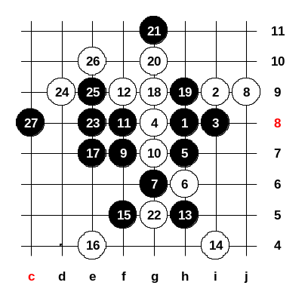
Hello everybody! Welcome to the renju class. Today I want to tell you about i6 opening, and show you one game that I played 7 years ago. We can begin now, please everybody see board 484515. Today we study another 4th move. We play 4-g8. Long time ago I believed this 4th move is very strong. However, black can sure win here. There are two winning 5th moves, h7 and j9. First we will look h7. We will try now the strongest white defense - 6-h6, the net style. Old times I believed black has no win here. But after some time I found even two wins here. Amazing! The European style win is 7-g6 and Japanese style win is 7-j7. I teach you the 7-g6 because it is easier to learn. Of course 8th move must be j9. If 8-f5 then 9-j7, 10-j8, 11-h9, 12-g10, 13-k8 and win. After correct 8th move at j9, black continues attack with f7. The strongest white's defense is 10-g7. In 1993, I believed that white could defend here. I even played such game as white in world championship. I won the game as white at that time against Stefan Karlsson (Sweden). He played 11-g9 at that time, but it is not good move. But one year later, 1994, he won me with 11-f8. I show you the way how he won me in 1994. The 11-f8 is the first step. White must block it above - 12-f9. If white plays 12-f6 then black next move is g9 and easy win. But now after 12-f9, the 13-g9 move is not good because then white stops 14-e7 and black has nothing. Stefan Karlsson showed a good win style here: 13-h5!! I thought a long time, to stop this three at e8 or i4. So hard. I counted, if I play white 14-e8 then Stefan will play 15-g10 and after that I cannot see any defense move. Black is attacking all around. So I finally decided 14-i4 is better, I tried it. I thought he will play 15-g9 and then i can play white 16-e7.... But he found a beautiful idea, 15-f5 and 17-e7, win!! I tried some defense moves as white, but useless. I tried white moves 18-g9, 20-g10, 22-g5. Can you see the black win here? You can tell me. I am waiting your moves. ^^
If e11, then white d11... OK we try e8. And then? After 25-e9 white must put 26-e10. Yes, d8 is win indeed, but you need learn to play always shorter if possible. It is good style to play c8 now, gives two 4x3 threats. We will close this example game now and open new board.

Jan 20 23:58
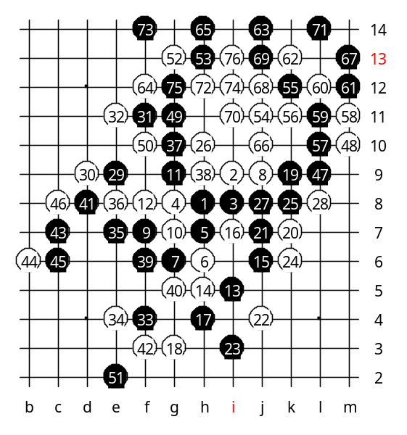
Now I will show you the famous game from the World Championship 1993, I play white against Karlsson. At that time, he used another way for black attack and he failed. White defense moves were all very good, you can learn from this game. Stefan Karlsson played 11-g9 in the year 1993. This is still very strong for black, so white defense must be very careful. This g9 seems to connect both left and right sides. So hard to defend against such power. The 12-f8 !! Look at this move. Usually a three or four is not good move for defense, remember that! But this situation is exception. Because black is attacking in left and right sides, I cannot put simple stop in one side because the other side would still be strong for black. But now I found idea, I played that defense three. If he stops it at left side, then I play next white move at left too. But if he stops my three at right side, I will play at right side too. This is how I solved the defense problem in two sides. Stefan thought about next move for a long time and then he decided to play i5. The next white move is easy to guess. Can anyone of you guess it? Yes, h5 is the move i played. ^^ Look at the position now, thanks to the stones f8 and h5, white has defended both left and right side against black attack. Then he continued attacking with moves 15-j6 and 17-h4. He still tried to connect his left and right side, but no use. White defense is strong. So he finally understood that black cannot win and he began to defend... 19-k9. The 23-i3 seems attack move, but is bad move! Even though black makes many lines, they are weak lines, no power in those lines. Therefore white can play active defense moves (stop black line and make its own white line). Now he wants to stop my line, but he is also afraid I will go attacking in upper side, so he thought the best 25 is k8. But I still tried to set up white attack above. Not easy. The 26-h10 is a good move. Next black moves 27-j8 and 29-e9. Black has no hope to win this game, so he tried to play actively and block all white lines. He played 31-f11 !! Look at this move, he is defending, he took a good white attacking point and same time he created black diagonal line. Besides, I became to afraid his next move at e11, so I continued my defense. He is playing very well, he is taking away the board space from white, later I will have less space for white attack. This is very good defense tactics. This game was played in the first round of the world championship in 1993, so both players were quite nervous. He played f4 now. The 33-f4 is good defense move, because f4 point was good point for white. Of course I had to stop his 4x3 threat. He continued to play actively for several moves. Look at the situation now! This is the key moment in this game! Black played very actively, he blocked almost everything. If white continue simple defense, for example 42-c7 then black plays 42-j11 and white cannot win this game anymore. Is draw. In such cases, when white wants to win, you must find very good moves! White must play so that black CAN NOT play in upper side first. If white wants to win this game, white must self play the upper side first. But white cannot play upper side now because black is winning in left side. So, white will still defend the left side, but there is one good move for white - f3!! F3 will defend the black attack on left side, and same time does not let black go to upper side because white suddenly became strong below. Now the following moves are the fight about "who will first have a chance to play a stone in upper side". If black will first have chance to play stone in upper side, the game is draw. But if white will play first in upper side, then white has good chances to win there later. Next moves are: 43-c7, 45-c6. Finally, black had to play 51-e2 and defend below. White tactics was successful - white can first play a stone in upper side! The following black moves are good defense moves, but already too late, white attack is too good. After 57-L10 white has straight win. And now white wins by VCF. This is very beautiful win because it ends with forbidden 4444. It is very seldom happen that 4 black fours become together in one trap. Very beautiful! ^_^
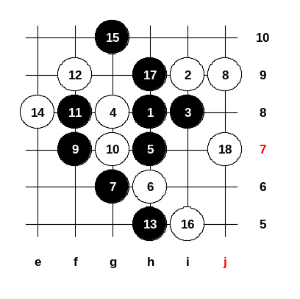

Jan 21 00:06
This is the homework for this week. You must find black sure win here. Please write this to game discussion when you find the answer. Thank you everybody for joining the class! Have a good sleep! See you next Thursday! ^__^ Thank you, 紫雲仙 , for help! ^__^

看海 : Jan 21 00:28
b19-h10 w20-h11 b21-e10 w22-f10
b23-c8 w24-d9orb7 b25-f5 w26-e4
b27-d6 四三手 白如何擋黑皆攻勝

萬盤棋 : Jan 21 05:27
Good answer !^__^! 我提供一下為何白18手不下f11呢?
If 18-w-f11,then 19 b-j6
(1)20-w-k5,21-b-h10,22-w-h11,23-b-g9,24-w-e7 or i11,25-b-f-10,black win四三勝
(2)20-w-(f10 or i7),21-b-j7,22-w-k6,23-b-j4,24-w-j5,25-b-f5,26-w-e4,27-b-f4,28-w-f6,29-b-i4,30-w-j3,31-b-g4,black win又是四三勝
(3)20-w-g9,21-b-j7,22-w-k6,23-b-j4
(a)24-w-(j8 or j5),25-b-g4,26-w-i6,27-b-i4 black still win 黑又勝
(b)24-w-j3,25-b-j8,26-w-j5,27-bk8 black win 黑再勝
(4)20-w-j4,21-b-k3,22-w-i7,23-b-g4,24-w-j7,25-b-h3,26-w-f5,27-b-j3 black win 黑勝
In my view, no matter how did white to block the black ,black still win
不管如何，黑子在這裡似乎必勝，假如你有妙手，歡迎提出參考 ^__^ !

